**Transition from Gravity Forms to Normal HTML Forms**

**Existing Functinoalities**

**1.**

On Radio Button selection respective products will populate

2.

On selecting Construction/Seasonally  
Respective products Populate on below of the page. There are 7 Product for category Construction/Seasonally

3.

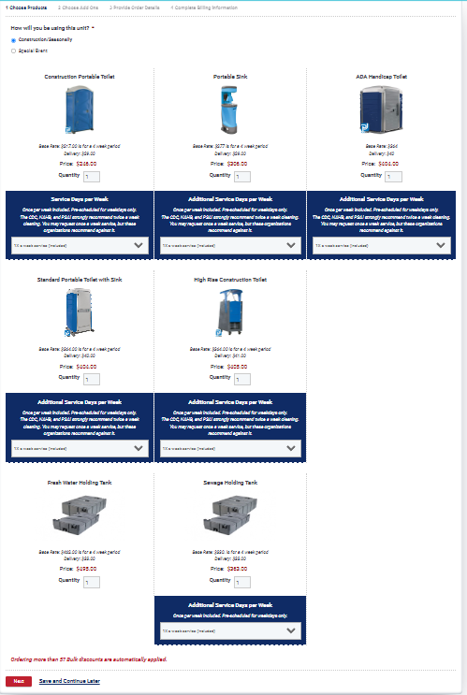

Each Product has its own Additional services on select dropdowns. Here are the details

1. Construction Portable Toilet (Default Qty = 0)

Base Rate: $217.00 is for a 4 week period

Delivery: $29.00

Price:

$246.00

Service Days per Week

Once per week included. Pre-scheduled for weekdays only.

The CDC, NAHB, and PSAI strongly recommend twice a week cleaning. You may request once a week service, but these organizations recommend against it.

**Included Service in Product Order** – 1x a week Service (included)

